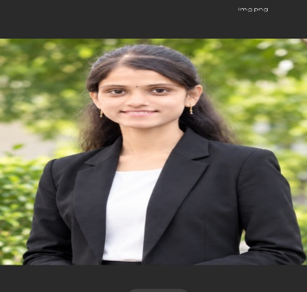
SHRAVANI PATIL
Email Id: patilshravani307@gmail.com
Mobile: 9588489640
Address: Pokharani. Tal-Walwa, Dis-Sangli Mharashtra 416301

CAREER OBJECTIVE
To build a successful career in the field of Computer Science by utilizing my technical knowledge and skills. I am eager to learn new technologies, gain practical experience, and contribute effectively to an organization through my dedication, teamwork , and problem-solving abilities.

EDUCATION
Bachelor of Science(B.Sc.) - Computer Science | Smt. Kusumtai Rajarambapu Patil Kanya Mahavidyalya , Ishwarpur . | Shivaji University , Kolhapur | Currentlu pursing – 3rd year
Higher secondary (PCM) | February-2024 | 65.50%
Matriculation (SSC) | March-2022 | 89.60%

TECHNICAL SKILLS
C / C++ / Java / Python
HTML / CSS

PROJECT
- Personal Portfolio Website
Developed a responsive personal portfolio website to showcase my profile, skills, projects, and contact information.
Designed a clean and user-friendly interface.
Implemented the website using HTML, CSS, and Javascript.

- Online Bookstore Website
Developed an online bookstore website to display and explore books in an organized manner.
Created user-friendly pages for browsing books and viewing book details.
Implemented the website using HTML, CSS, and Javascript.

PERSONAL DETAILS
Name – Shravani Patil
Date of Birth – 30/07/2006
Languages Known - Marathi, Hindi, English.
Address – A/P. Pokharani, Tal-Walwa , Dist-Sangli.

